8 Way Vertically Mounted Surge Protected Rackmount PDU - UK Sockets (PDU-8WS-V-SP-1U)

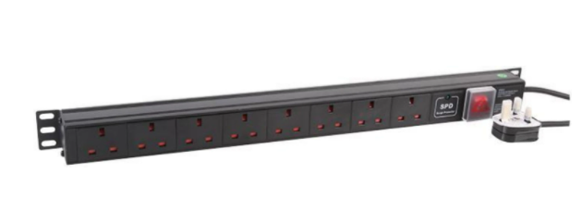

Description:

The LMS Power PDU-8WS-V-SP-1U is a high-quality surge protected, vertically mounted PDU (Power Distribution Unit) that simply fits within the universal mounting brackets of data, telecom and server cabinets.
Providing piece-of-mind of integral electrical surge protection against common power surges and electrical spikes to devices including Ethernet Switches, Servers, UPS, NAS and of course cabinet accessories including cooling fan trays.
Robust, alloy design complete with rackmount brackets fitted, high-quality Neon Switch and of course UK output sockets together with a high quality, BSI-fitted
13 Amp UK plug.

Key Features:
Standard UK 3-Pin power outlets for your appliances
Built-in surge protection for critical device protection
1U vertically mounted attaches to internal profiles
Neon On/Off Rocker switch to prevent accidental turn off
Backed up by LMS Power's exclusive 3-year warranty

Product Code:
Part Number: PDU-8WS-V-SP-1U
EAN: 8400800024251
Weight: 1.5Kg approx

Technical Specifications:
Warranty LMS Data 3-Year Warranty
Chassis 1U vertical PDU with mounting brackets
Output Sockets 8 UK 3-PIN Sockets
Power Input Fitted UK 3PIN BSI Plug 13 Amp
Flex Length 1.8 metres (approx)
Power Control On/Off Rocker Switch (illuminated)
Power Rating 4000 Watts (approx) Surge Protected

Supplied With:
PDU-8WS-V-SP-1U 8 Way Vertical PDU
Cabinet brackets (Fitted)
* Specifications and product design are subject to change. E&OE.

Looking for a more specialised Power Distribution Unit (PDU) with integral surge protection and grounding validation features? The new LMS Data PDU-8WS-V-SP-1U is a high-density, vertical placement PDU which features 8 standard UK power socket outlets to provide power to networking, data centre, PBX and broadcast level power devices within the data cabinet enclosure. Integral status LED for electrical earthing indication is an important safety feature, reducing the risk of electric shock for both the attached devices and of course installation staff. Surge protection is of course built-in to all outlet sockets, increasing both MTBF and reduced data corruption for attached computing and networking devices. Coupled with a long-life, illuminated I/O Switch, certified UK power sockets together with a generous length power cord, all of which are BSI rated and fused for full compliance.

specifications:
8-way UK plug-socket style Power Distribution Unit (PDU)
Compliant, 13-amp UK 3-pin socket output
Illumination On/Off power-input rocker switch
Integral Surge Protection and Grounding Confirmation
Generous length, 1.8 metre (approx.) power cable
Lightweight design with a 1U high form-factor design
Ideal for vertical placement in data or server enclosures
Ideal for LAN, audio-visual, PBX, VoIP and CCTV applications

